**TASK -02**

IP Addressing and VLAN Segmentation

|  |  |  |  |
| --- | --- | --- | --- |
| VLAN | Name | Subnet | Usage |
| 10 | Management | 192.168.1.0/24 | Admin PCs, switches |
| 20 | Guest | 192.168.2.0/24 | Guest PCs |

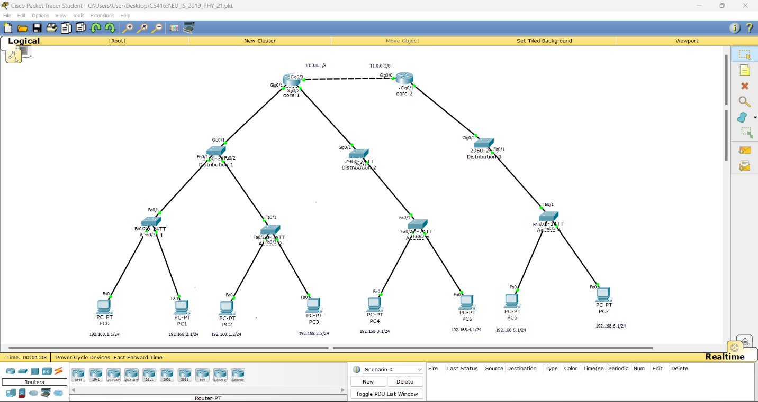

Access layer (switch 1-config)

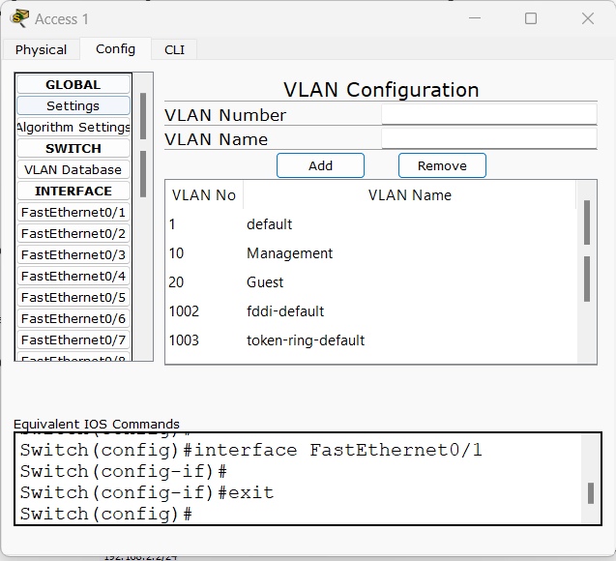

Distribution layer (Switch 1-config)

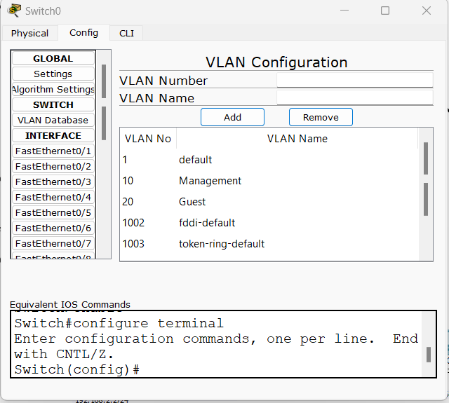

Multilayer (Router 1-config)

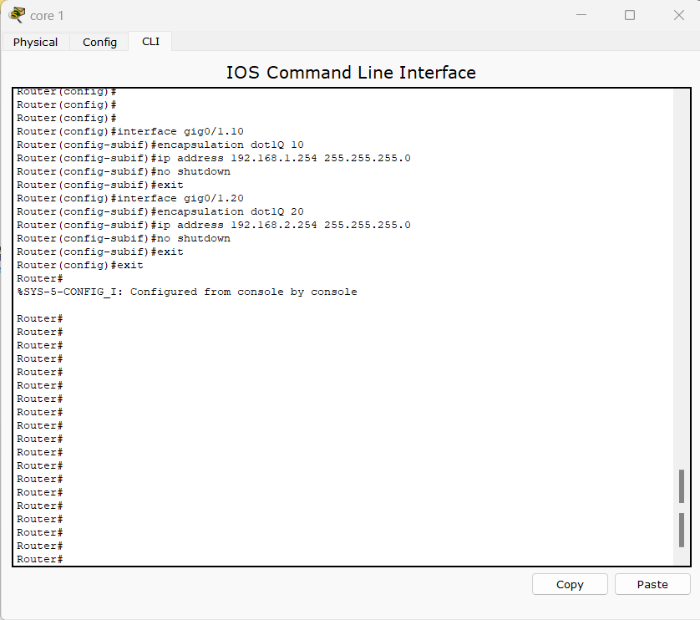

Index Number: PS2771

Registration Number: EU/IS/2019/PHY/21